# CS 255 System Design Document

## UML Diagrams

### UML Use Case Diagram

### UML Activity Diagrams

### UML Sequence Diagram

### UML Class Diagram

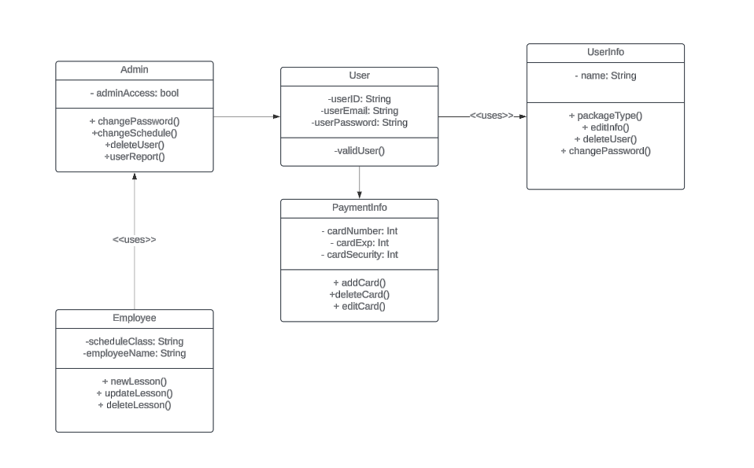

## Technical Requirements

***Hardware Requirements:***

* *At least one physical server or a dedicated server with adequate storage for database and website data.*
* *Reliable internet connection and power sources for both host and client systems.*
* *Networking equipment, including cables, Wi-Fi routers, or Ethernet connections.*
* *Monitor, keyboard, and mouse for server interaction.*
* *Client devices: Desktop or laptop computers or mobile devices to access the website.*

***Software Requirements:***

* *Host Systems:*
  + *Windows Server operating system for stability.*
  + *SQL Server for database management (most stable release recommended).*
  + *Docker software for managing virtual machine (VM) traffic.*
  + *Web server software such as Apache.*
  + *Security software to safeguard against malware and hacking.*
  + *Backup software for database and website data.*
* *Client Systems:*
  + *Web browsers (Edge, Chrome, etc.).*
  + *Operating systems (Windows, Linux, Mac, etc.).*
  + *Security software to protect sensitive information.*